Go to \\rtsbs\IT\SSIS conversion from excel to SQL\BI for insertion only\Real Insertion Project, open integration service project 2.sln. Click on “Insert Records”, you will see an interface below

Under SSIS toolbox, drag “execute SQL Task” onto control flow if you want to create a SQL task

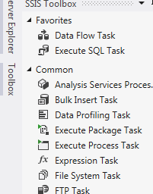

Make a connection to SQL server and write any SQL statements you want inside red circle

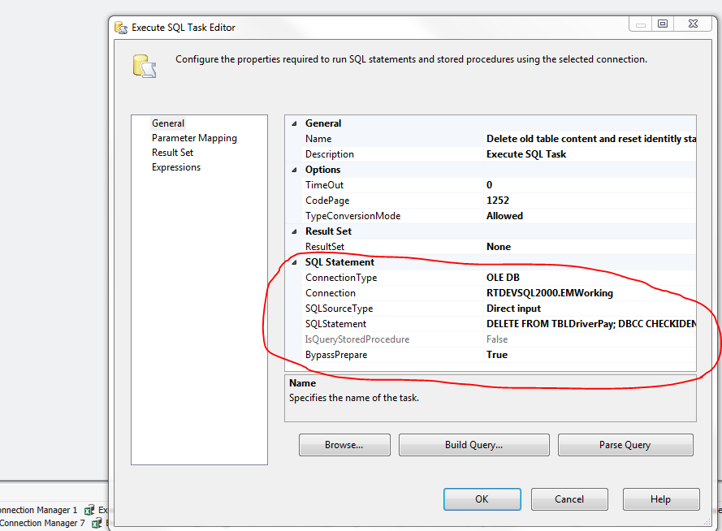

Double click “Insert Records”, you will see an interface below

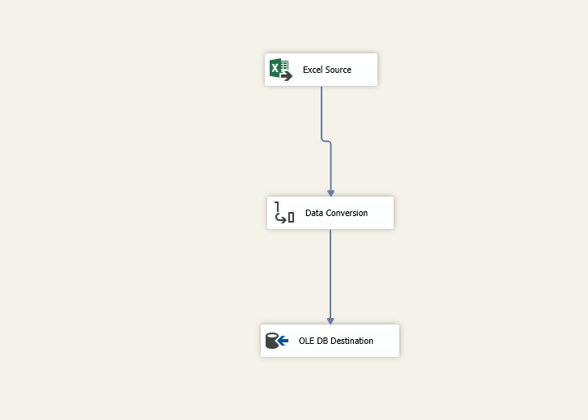

Click on Excel Source, it will open a new excel source editor, then click on “new” button.

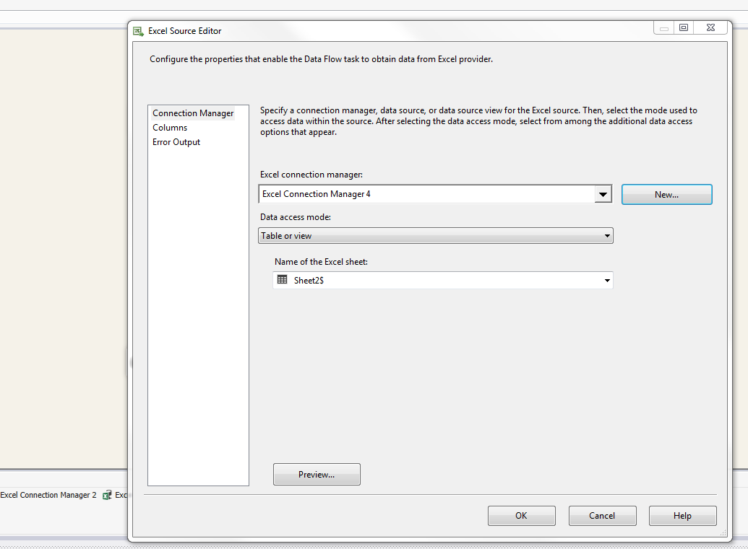

Enter the excel file path below:

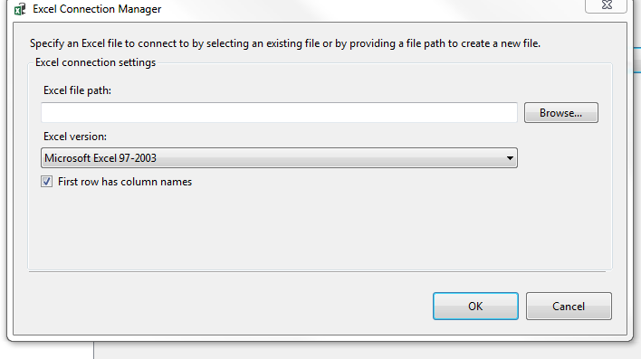

Pick the name of excel sheet you want to import

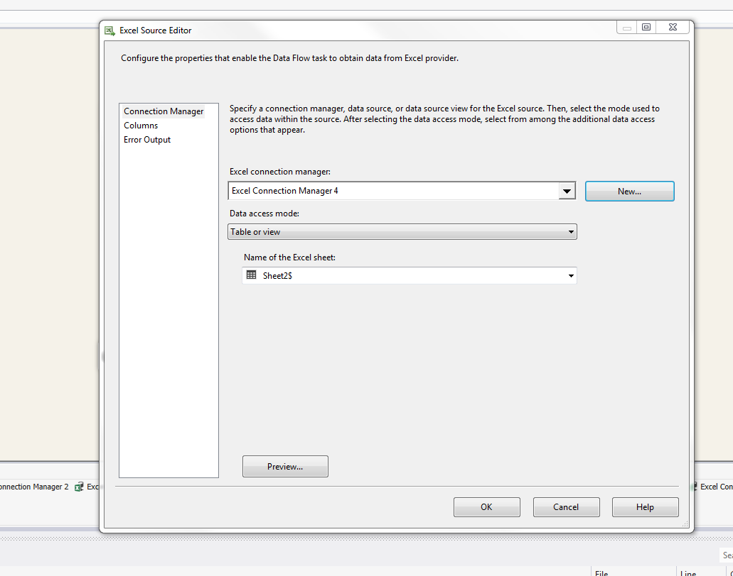

Click on “Build” On the top and build the solution

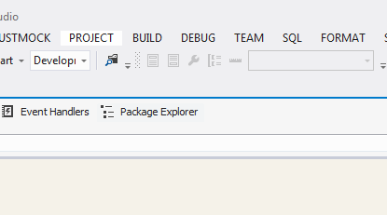

**Right Click on “Packages.dtsx” and click “execute package” to run the project, then the excel data will be**

**Converted to our database**

